Power BI Assignment 3

1. **List and explain different Power Bi products?**

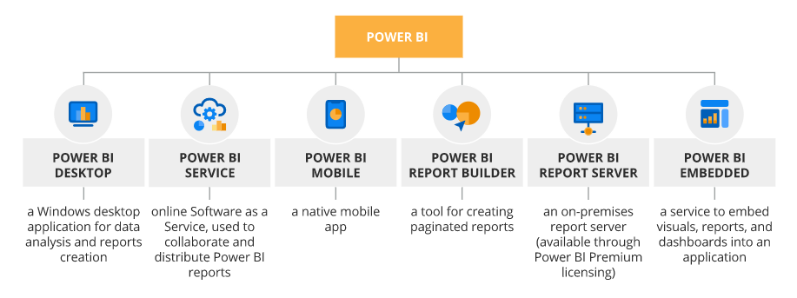

1. **What limitations of Excel, Microsoft solved by PowerBi?**

* Power BI can connect hundreds of data sources to get data using native connectors or partner connectors compare to Excel can connect less than hundred data sources to get data.
* Power BI is very efficient at processing and analysing very large data sets (millions of rows) whereas Excel can be slower and less performant compare to Power BI for same large dataset.
* Power BI UI is great self-service UI compare to Excel whereas Excel offers familiar UI consistent with other Office products.
* Power BI has Q & A and Functions to consume Azure Text Analysis which can be deal breaker not only when Power BI compared to Excel but also other BI players like Tableau, Looker etc.
* Power BI has plethora of visuals both native and third party which just make Business Intelligence a lot easier compare to Excel. I have seen some partners have done amazing job to offer extend visualizations in Excel but Power BI would stand out for design elements and modern look and feel.
* Excel is part of Office 365(Microsoft 365) and Office Install so it is cheaper option when compared to Power BI’s Pro or Premium service and other licensing needs.
* Power BI is part of Microsoft 365 (Premium E3, E5, Business) or as a standalone license (with some prerequisite) and inherits security and identity infrastructure of Azure AD and Groups and Workspaces which makes it very efficient, secure and trustworthy way to handle data in more simple and complex implementations alike. Excel does inherit some of it but Excel is not meant to be used as Self Service BI so it would never be positioned to compete with Power BI.

1. **Explain PowerQuery?**

* Power Query is an application for transforming and preparing data. With Power Query you can get data from sources using a graphical interface and apply transformations using a Power Query Editor. Using Power Query, a business intelligence tool offered by Microsoft Excel, you can import data from any number of sources, clean it, transform it, then reshape it according to your needs. In this way, you can set up a query only once, re-use it later by simply refreshing.
* As the name suggests, Power Query is the most powerful data automation tool found in Excel 2010 and later. Power Query allows a user to import data into Excel through external sources, such as Text files, CSV files, Web, or [Excel workbooks](https://www.simplilearn.com/tutorials/excel-tutorial/create-workbooks-in-excel), to list a few. The data can then be cleaned and prepared for our requirements.
* Power Query has several useful features embedded in it, such as the appending of data and creating relationships between different data sets. This is called the merging of the data sets. We can also group and summarize data with the help of the tool. Needless to say, it is a very useful tool.

1. **Explain PowerMap?**

* Microsoft Power Map for Excel is a three-dimensional (3-D) data visualization tool that lets you look at information in new ways. A power map lets you discover insights you might not see in traditional two-dimensional (2-D) tables and charts.
* With Power Map, you can plot geographic and temporal data on a 3-D globe or custom map, show it over time, and create visual tours you can share with other people. You’ll want to use Power Map to:
* Map data    Plot more than a million rows of data visually on Bing maps in 3-D format from an Excel table or Data Model in Excel.
* Discover insights    Gain new understandings by viewing your data in geographic space and seeing time-stamped data change over time.
* Share stories    Capture screenshots and build cinematic, guided video tours you can share broadly, engaging audiences like never before. Or export tours to video and share them that way as well.

1. **How powerBi eliminated the need to host SharePoint Server on premises?**

* You can build a Power BI report that will refresh online without the need to install a gateway.
* Everyone has easy access to the files for editing and storage
* Power BI workbook with a number of sources seems to take 4-5 times longer to refresh when compared to the same workbook pointing to a file server.
* Share point is heavy technology investment over the years created a dependency on SharePoint on-premises.
* Microsoft's SharePoint is an Intranet solution that enables users to share and manage content, knowledge, and applications to empower teamwork, quickly find information, and collaborate across the organization. Microsoft Power BI has better pricing, better features in the trial version.
* Power View for SharePoint is available in SharePoint BI when Reporting Services is configured in SharePoint Mode.  Generally, there's not feature differences between Power View for SharePoint and Power View for Excel - but there is one notable difference. Power View for SharePoint can export a copy of the report to PowerPoint, whereas Power View for Excel does not have this feature.
* Currently only Power BI offers the mobile app which is available for Windows 8.1 devices - iPad support due out by the fall. This is due to Microsoft's cloud-first strategy.
* SharePoint BI has no notion of a Data Management Gateway (DMG), whereas Power BI does since it's a hybrid type of environment partially on-premises and partially cloud-based.
* As part of the Power BI DMG and data source options, Power BI also offers the ability to easily [expose tables and views as OData feeds](http://msbiacademy.com/?p=7241) for users to consume. This can serve as a 'friendlier' way for users to access data.



1. **Explain the updates done in Power Bi Service (power BI 2.0) as compared to older version ?**

After setting up some tabular cubes, Microsoft Power BI reflects a good promise in the future  
for Self Service and Quickly creating Dashboards.  
Here is what I see the benefits and drawbacks so far.  
  
**Pros:**- Great data load and instant result experience with Tabular Model as the data source.  
- UI somewhat customizable. But still requires more functionality on customizing graphs, titles and data field names.  
- Security is another important thing that Power BI has well though of by placing it at the Cube level so if anyone shares a dashboards the receiver can only sees the data he/she is allowed to.  
- Using Power BI Designer One can connect to many types of data sources, but again requires technical knowledge of mapping data elements to create a final model.  
  
**Cons:**  
- Tabular Model with hierarchy don't show up. That was a great disappointment for any BI developer to not see the hierarchies. Nevertheless Microsoft Promises to provide in near future.  
- Measure Groups don't reflect as they are designed grouped and perspectives are shown as a different database model.  
  
- Drill down on the front end is not available accept from dashboard cue card to the detail report that could be of several pages.  
  
- Still no luck to access Dimensional Cube.